# MultiTalent

## Scoring machine

## Software update

**USER MANUAL**

The MultiTalent scoring machine can be updated for free according to the steps below.

Requirements: computer with internet access, USB A-USB B cable,scoring machine switched ON

Step 1: Turn on your computer and scoring machine as well. Connect them with an USB-A-USB-B cable:

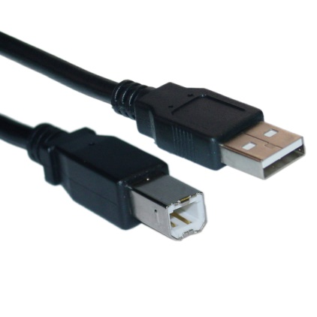

Step 2: Find the uploader filet on our website on the related product page

<https://shop.pbtfencing.com/media/fes45/Fes45Updater.zip>

Step 3: Download and save the file on your computer 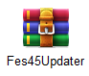

If you have a previous version of the uploader file and its extracted files on your computer delete them first and remove also the FES45Uploader programme.

Step 4: Extract the dowloaded latest file version and find in the folder the FES45Updater.exe file an RUN the programme.

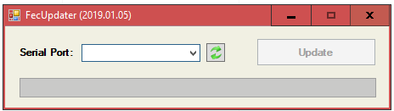

The computer and uploader programme detect the connected device via USB and use the adequate port number. Click on the UPDATE button and while updating the scoring machine turns off and on again automatically. The programme is indicating once the process finished.  
Then turn OFF the scoring machine, unplug the cable, the apparatus is up to date.

If the programme indicates an ERROR the devices are not connected on the right port.  
In this case click on the refresh button or try to find manually another port.